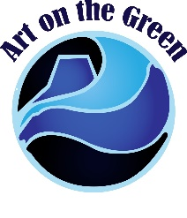
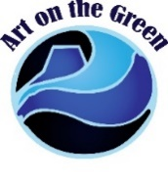
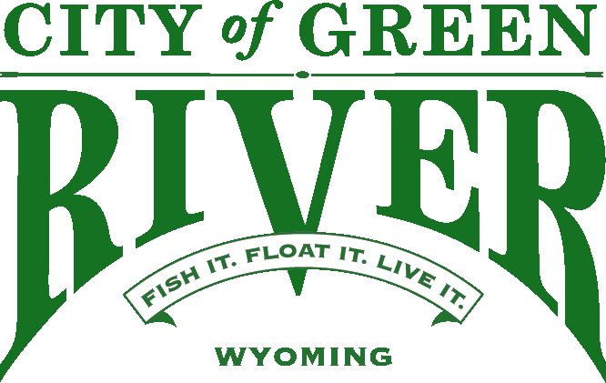
16th Annual Art on the Green 2021
24-hour Live Sculpting & 2D Competition
Competition Dates: August 20-21, 2021 Application Deadline: postmarked by July 9, 2021
General Rules & Information

2D & 3D competitors will provide:
a. The armature, base, and heating device for clay sculptures.
b. The easel, canvas, paint/pencils, brushes and matte or frame (to display the final work)
c. Individual light source (i.e. table lamp)

The City of Green River will provide:
a. Clay – 20 lbs
b. A protected area (building and/or tent)
c. A work area approximately 4' X 10'
d. A work surface 30" X 6' table and chair
e. A 30" x 6' space or table to display and sell your table size artwork

Competition Rules:
1. 3D pieces using clay provided by GRAC may not exceed 16" in height, 20" in length, and 20" in width; 3D pieces using media provided by the artist may be any size deemed appropriate by the artist. These pieces must fit on a table, stand or easel and be easily moved for judging. Two Dimensional pieces may not exceed what will fit on an easel that is provided by the artist. Size of the pieces for 2D competition should also include the frame. This is an individual competition, all sculpting and/or drawing/painting will be done by the artist (no helpers).

2. The entire 2D or 3D piece must be completed and professionally displayed in the given time allotted in order to be judged. (24 hours)
a. Artist is prohibited from signing their work until after the official judging has concluded.
b. Competition work may NOT leave the premises. If the work of art leaves the artist will be disqualified.
c. Artists’ may only submit one piece of work for the competition, or specific arrangements must be made with the Green River Arts Council.
d. All 2D & 3D art must be 1st time pieces. (Original work - no copies)
e. Only the armature that will be used for the competition may be pre-built.
f. Pre-built parts for the sculpture are not permitted.
g. Only hand tools are allowed for the competition.
h. An under-drawing/painting in neutral colors may be pre-drawn.
Art on the Green Timeline
July 9– Postmark deadline to receive
your application and payment

July 16– Artist packets mailed
July 23- Digital biography and photo must be received to be included in the brochure

August 20 – Mandatory Artist Meeting
10:00 am, Expedition Island Pavilion

3. Approved reference materials:
a. Artist's own sketches
b. Photographs
c. Multiple image sources
d. Artist maquette

4. Prohibited reference materials:
a. Photographs of other artists' work
b. Other artists' copyrighted material

5. Artists will be allowed to bring art for display and sale, and submit pieces for the silent auction (table top size only).

6. Artwork created at the competition may be sold through a silent auction process following the competition.
A 20% commission of all sales during the competition will be collected by GRAC.

The Green River Arts Council reserves the right to refuse the display of artwork which is not family oriented. 
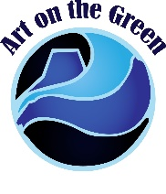
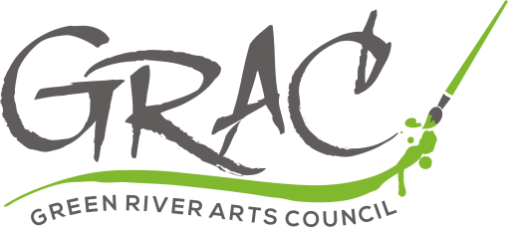
ARTIST APPLICATION
Please fill out, sign and return this application, POSTMARKED by July 9, 2021.
Name __________________________________
Check List:
- Application postmarked by July 9, 2021

- A check for the application fee is enclosed

- Digital biography and photo emailed to cduncombe@cityofgreenriver.org by July 23, 2021

- 2-5 photographs of 2D or 3D your work

(Only if you have not previously submitted them)

Business affiliation (Optional) _____________________
Mailing address ________________________________
City, State and Zip ______________________________
Phone ___________________________________
E-mail address _________________________________
Shirt Size: ________
Does the Green River Arts Council have permission to share your
information with other organizations for art related
opportunities? _____Yes _____No

Please indicate your division and entry level:
2D entry__________ 3D entry _____________

__Professional ($110); __Semi-Professional ($60); ___Amateur/Hobbyist ($35);
__ High School ($25)

Artist entries will be dated and time stamped, and must be postmarked by July 9, 2021.

- Only artists that have not previously submitted 2-5 printed photographs of their 2D or 3D work need to submit them with the completed application.
- GRAC reserves the right to select quality competitors.
- If your application is not accepted your entry fee will be refunded.

Payment:
We accept checks and credit cards (Visa & MasterCard accepted)
Credit Card #________________________ Expiration Date_______ CVC# ________
Name on Card __________________________________________
Please make checks payable to:
City of Green River
1775 Hitching Post Drive
Green River, WY 82935
I, the undersigned, do hereby accept all liabilities for any and all personal injury or property damage that may occur during this competition. I agree to hold no liabilities, resulting from my participation regardless of fault, against the Green River Arts Council, the City of Green River, its employees, volunteers and/or anyone else associated with this competition. As a participating artist I give permission to the Green River Arts Council to use images of my artwork in the promotion of activities associated with the Green River Arts Council.
Signature:______________________________________ Date:

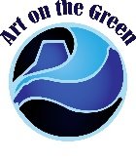
2021 Art on the Green
Live 24-hour 2D and 3D Art Competition
August 20-21, 2021

The Green River Arts Council is a City of Green River Mayor appointed volunteer board and each year in August they host this very unique event for artists and the public. Please take a moment to read over our rules and guidelines for this year’s competition. Each year the event is reviewed by the Green River Arts Council. It is the Council’s goal to make improvements to better the artists and spectators experience. Please call or email if you have any questions about the 2021 competition.

$11,600 Total Prize Purse
(For 2D and 3D Artists)
Judges’ Choice Purse Prize
Professional Semi-Pro Amateur /Hobbyist High School
1st Place $850 1st Place $350 1st Place $200 1st Place $150
2nd Place $550 2nd Place $250 2nd Place $150 2nd Place $100
3rd Place $400 3rd Place $200

Artists’ Choice Purse Prize
Professional Semi-Pro
1st Place $850 1st Place $350
2nd Place $550 2nd Place $250
3rd Place $400 3rd Place $200

Meal & Hotel Information
- Meals and snacks will be served during the competition
- One complimentary awards dinner ticket for Saturday night

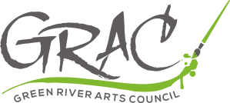
If you have any questions please feel free to contact our liaison:

Katie Duncombe
Recreation Supervisor
City of Green River
1775 Hitching Post Drive
Green River, Wyoming 82935

Phone: 307-872-0514

Thank you for your interest in Art on the Green!

